**Viewing Delegates in Workday**

1. As a delegate, log in to your Workday profile and click on your name in the right hand corner to view profile. If someone has delegated to you will see an option to ‘Switch Account’ – click on that.

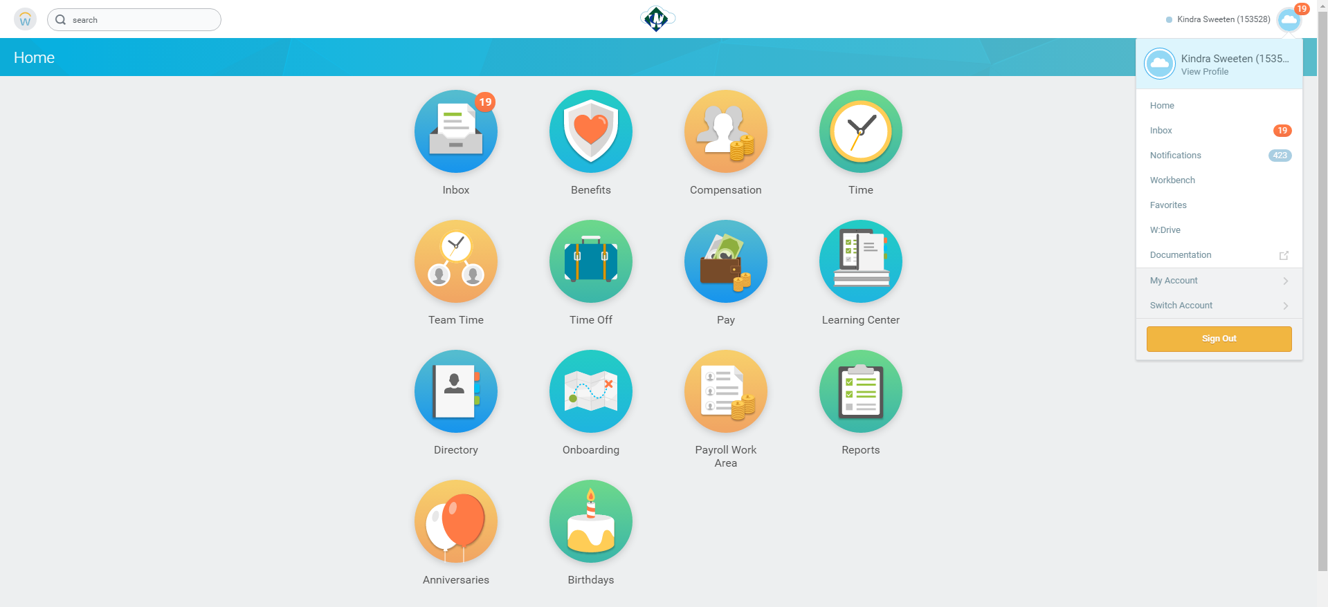

1. 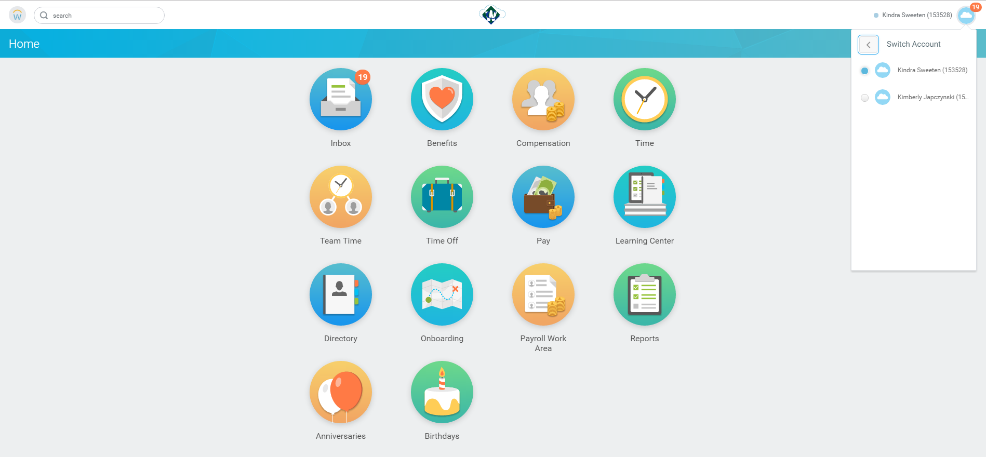Once you click on ‘Switch Account’ You will see the options of the person(s) who have delegated to you. Select the person’s name.

.

1. 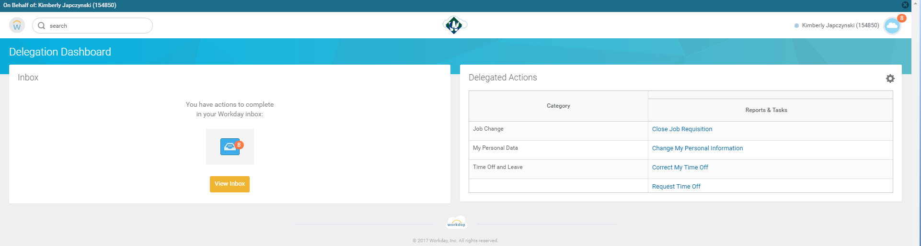Once you click on the name, it will bring you to the Delegation Dashboard. This will show any actions waiting your completion and what delegation actions you are able to perform on that employee’s behalf.
2. 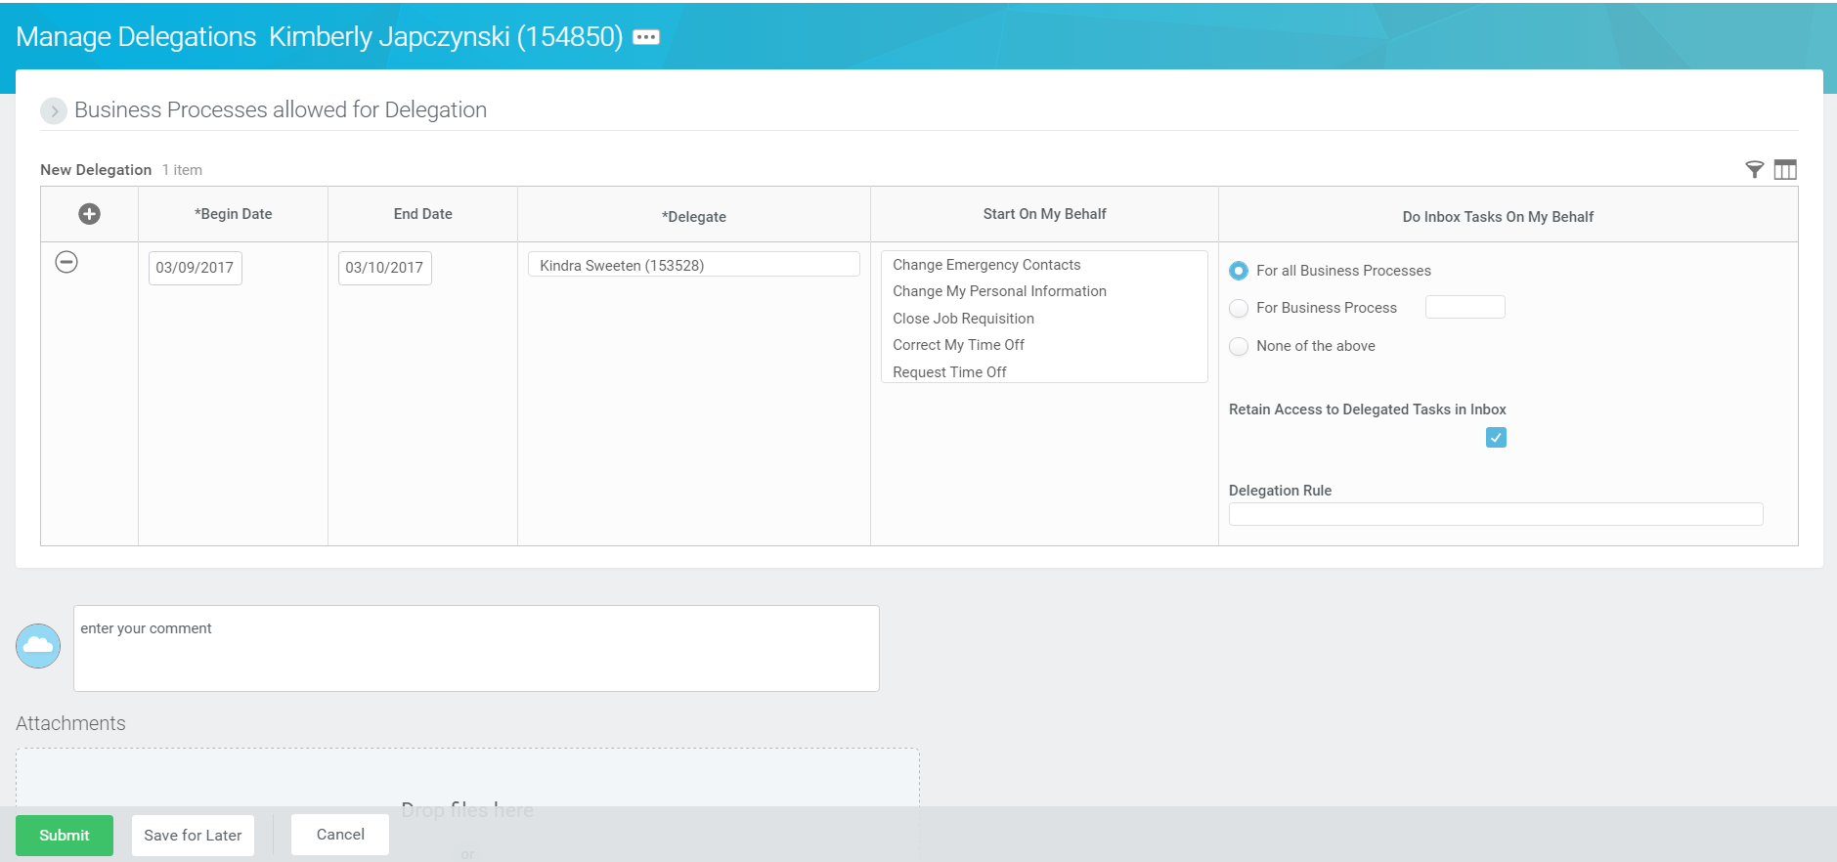Make sure if you set up a delegation that you select the bottom box so you are able to Retain Access to Delegated Tasks in you inbox.